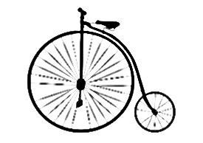 

Bikes for Tikes

**100% OF FUNDS GOES TO BIKES**

**ALL Bike BackerS WILL BE RECOGNIZED IN THE TRI-CITY HERALD on christmas day**

**Online donations can be made @** [**www.bikesfortikesnw.com**](http://www.bikesfortikesnw.com)

|  |  |  |  |  |
| --- | --- | --- | --- | --- |
|  | **Levels** | **Amount** | **Bikes** |  |
|  | **MEGA BIKES LEVEL** | **$4000.00** | **60** | **Additional Sponsorship Packages:** |
|  | **SUPER BIKES LEVEL** | **$2000.00** | **30** | Big Wheel, Helmets, Homeless teen shelters, Veterans shelters, Mid-Columbia Read a book program, etc. |
|  | **PLATINUM BIKES LEVEL** | **$1000.00** | **15** |
|  | **DIAMOND BIKES LEVEL** | **$800.00** | **12** |  |
|  | **GOLDEN BIKES LEVEL** | **$600.00** | **9** | **Bike Build Event Sponsorships:** |
|  | **SILVER BIKES LEVEL** | **$400.00** | **6** | Picture area, Air station, QC Station, Repair Station, sticker station, bike orders, Build Area Stage, etc. |
|  | **BRONZE BIKES LEVEL** | **$200.00** | **3** |

*the cost is averaged between bike sizes **All sponsorships will have right of first refusal the following year

|  |  |
| --- | --- |
| **CONTACT INFO - (please print legibly)** | |
| Recognition Name |  |
| Business Name: |  |
| Contact Person: |  |
| Address: |  |
| City, State, Zip: |  |
| Phone: |  |
| Email: |  |

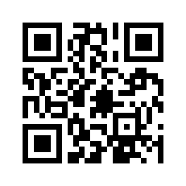

**2021**

**Non-profit 501C3 Organization (EIN 47-1230489)**

**Make checks payable to:**

**BIKES FOR TIKES Bill Me**

**1328 N Road 28 Meeting Request **

**Pasco, WA 99301 Sponsorship Info Request**

**509-545-1446**

**BIKESFORTIKES@ua598.org**